

***Entity Framework***

**Lab Guides**

| **Document Code** | **25e-BM/HR/HDCV/FSOFT** |
| --- | --- |
| **Version** | **1.1** |
| **Effective Date** | **20/11/2012** |

**Hanoi, 07/2019**

**RECORD OF CHANGES**

| **No** | **Effective Date** | **Change Description** | **Reason** | **Reviewer** | **Approver** |
| --- | --- | --- | --- | --- | --- |
|  | 01/Oct/2018 | TuTB create new | Draft |  |  |
|  |  |  |  |  |  |
|  |  |  |  |  |  |
|  |  |  |  |  |  |
|  |  |  |  |  |  |
|  |  |  |  |  |  |
|  |  |  |  |  |  |
|  |  |  |  |  |  |
|  |  |  |  |  |  |
|  |  |  |  |  |  |

**Contents**

Lab: Routing in MVC 4

Objectives: 4

Prerequisites: 4

Problem Description: 4

Guidelines: 4

Step 1: Open MVC project that created in NWEB.S.L001 4

Step 2: Update default route 4

Step 3: Run the project and check result 5

Step 4: Add new route 5

Step 5: Route Constraints 6

|  | **CODE: NWEB.S.L002**  **TYPE: SHORT**  **LOC: 100**  **DURATION: 30 MINUTES** |
| --- | --- |

# Lab: Routing in MVC

**Objectives:**

* Understand Routing in MVC.

**Prerequisites:**

* Download and installs Visual Studio (included .net Framework).

**Problem Description:**

* N/A.

**Guidelines:**

### Step 1: Open MVC project that created in NWEB.S.L001

### Step 2: Update default route

Update default route from Home/Index to Home/Contact

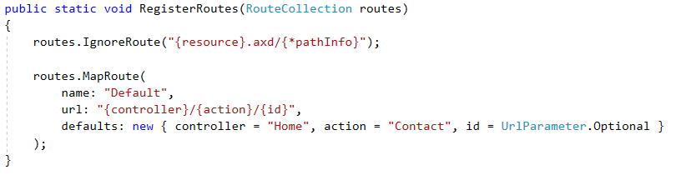

### Step 3: Run the project and check result

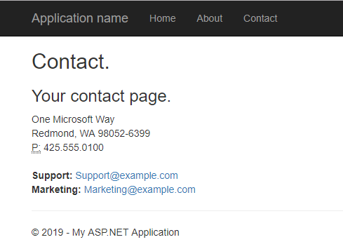

### Step 4: Add new route

Add Route named Student

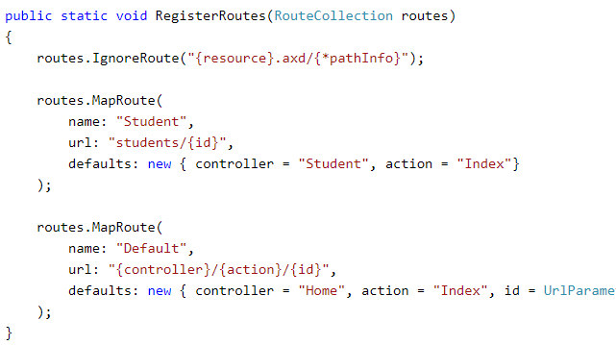

### Step 5: Route Constraints

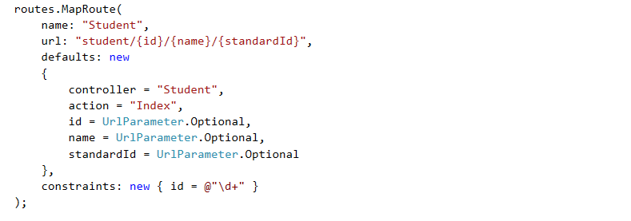

Step 6: Run the project and check result